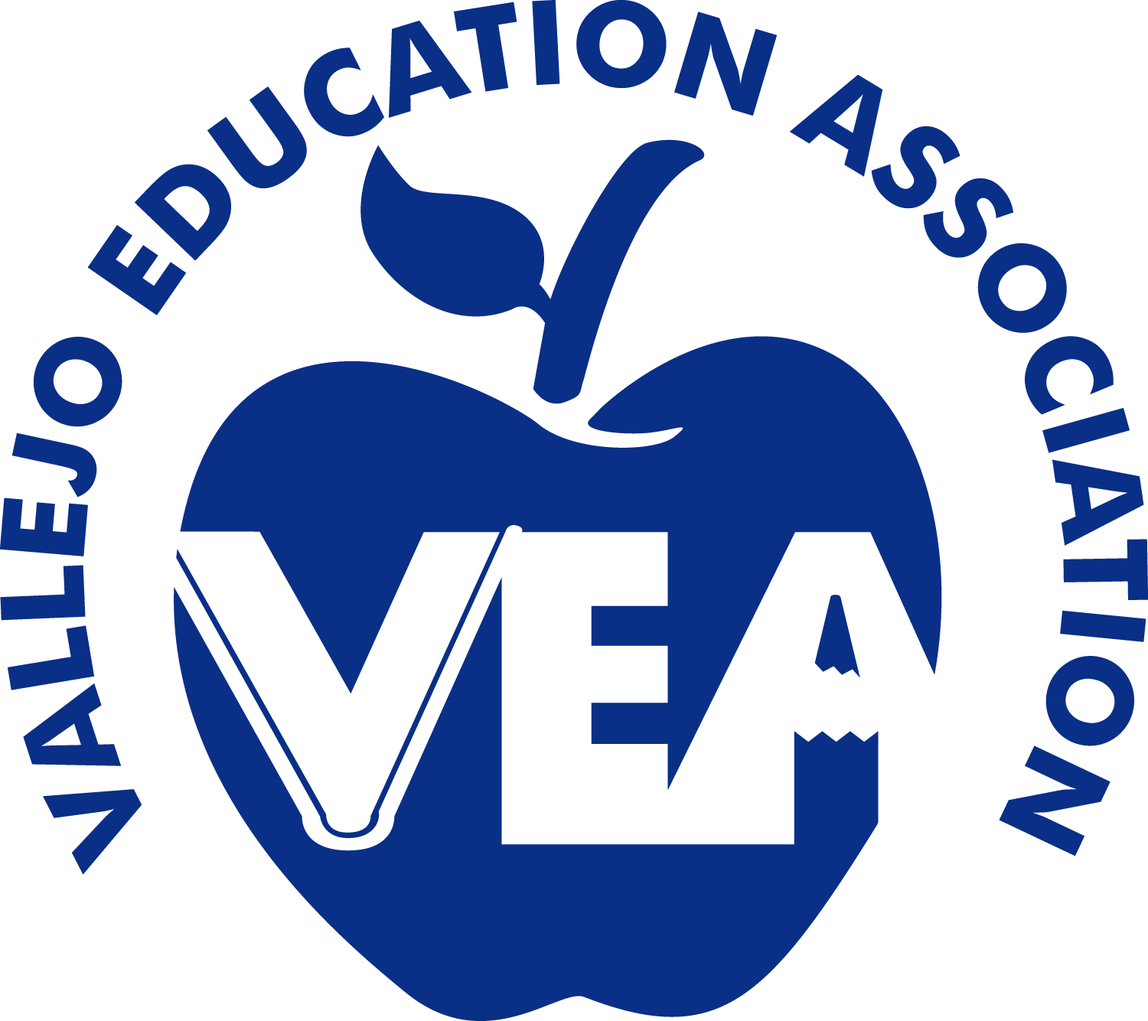

www.myvea.org
vallejoedassoc@gmail.com

301 Farragut Ave., Room #19
Vallejo, CA 94590
(707) 649-3926

The Vallejo Education Association supports quality neighborhood public schools and opposes privately- run unregulated charter schools that are harmful to Vallejo and all Solano County students.

WHEREAS, unregulated charter schools do not have an elected board of education and are not accountable to the public, and

WHEREAS, unregulated charter schools receive millions in taxpayer dollars but are not held to the same standard of accountability and they don’t sufficiently disclose how they spend tax payer dollars, and

WHEREAS, unregulated charter schools take funding and resources from students in our neighborhood public schools, and

WHEREAS, unregulated charter schools often exclude or push-out students that need extra help, such as children with disabilities, language learners, or children with behavior challenges, and

WHEREAS, unregulated charter schools are exempt from major sections of California Education Code that protect students, and

WHEREAS, the current rules regarding transparency and accountability have not been sufficient to support the oversight of charter school operations and the California legislature has not yet passed legislation such as AB 1478 and SB 808 to ensure more oversight, transparency, or accountability, and

WHEREAS, the Vallejo Education Association believes that undermining local public schools undermines the future of working families in the region,

THEREFORE, BE IT RESOLVED THAT the Vallejo Education Association opposes bringing more privately-run unregulated charter schools that harm our students into Solano County.

AND BE IT FURTHER RESOLVED, that the Vallejo Education Association urges the Vallejo City Unified School District and the Solano County Solano County Office of Education to explore a process, working with State and Local elected officials, for bringing forward requirements that applications for charter schools have the same level of oversight and accountability that Public Schools provide.

The foregoing resolution was acted upon at a regular meeting of the Vallejo Education Association and approved unanimously on December 7, 2017.

Attest:

____________________
Sheila Gradwohl
VEA President

